Use Case-1: Petrol Use Case

Table Creation-

create table petrol (distributer_id STRING,distributer_name STRING,amt_IN STRING,amy_OUT STRING,vol_IN INT,vol_OUT INT,year INT) row format delimited fields terminated by ‘,’ stored as textfile;

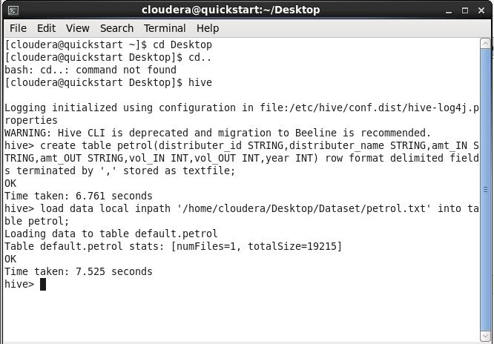

Query 1-

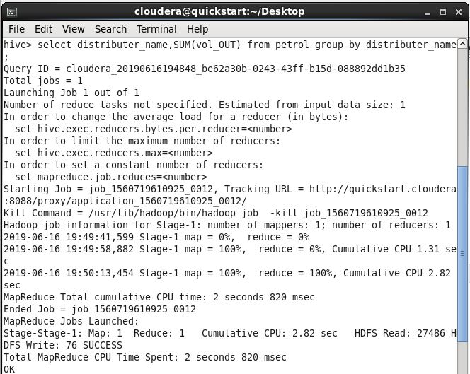

Output

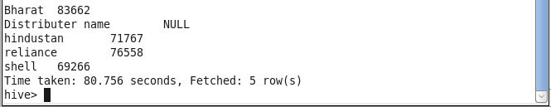

Query 2-

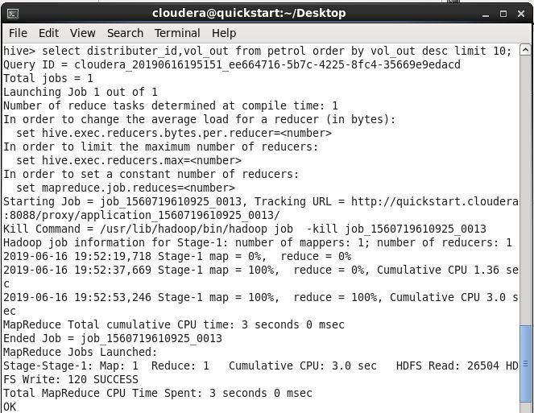

Output-

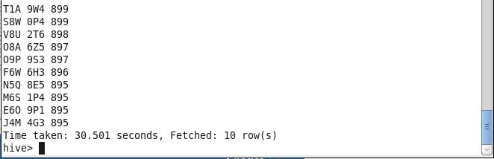

Query 3-

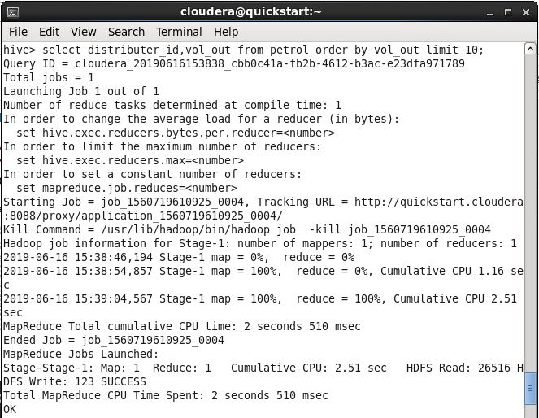

Output-

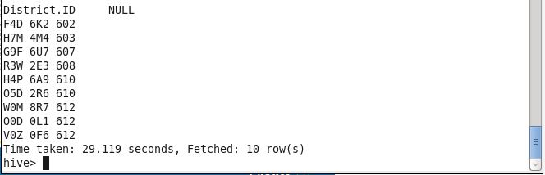

Query 4-

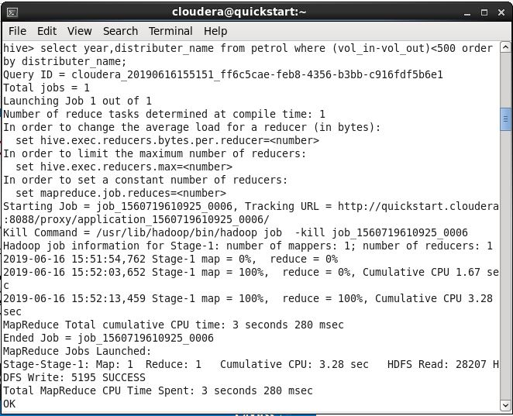

Output-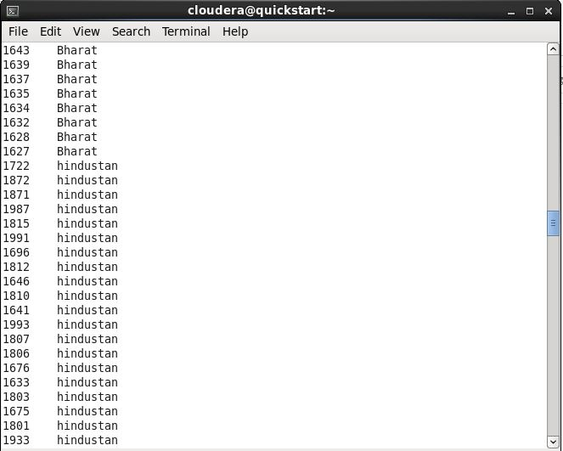

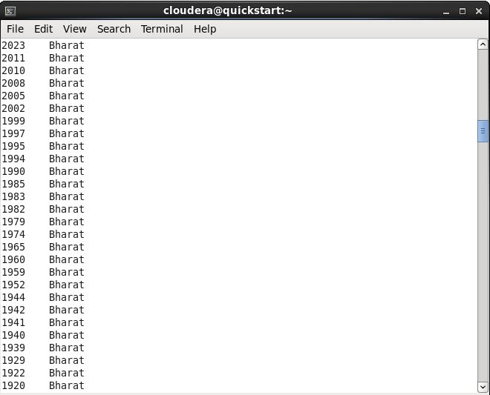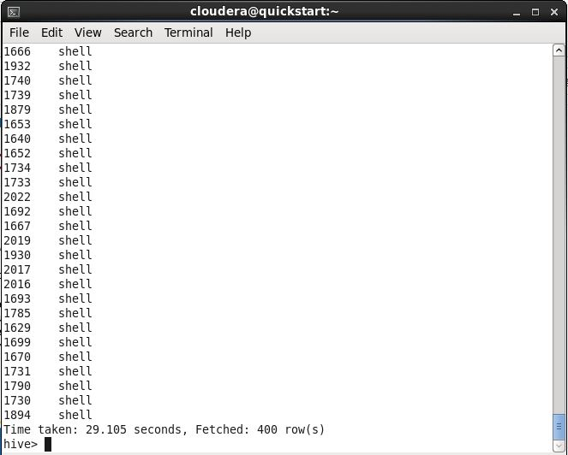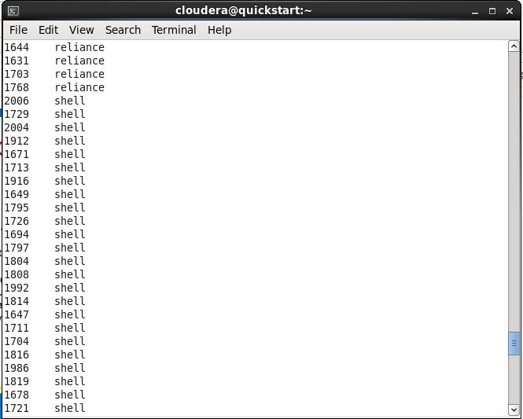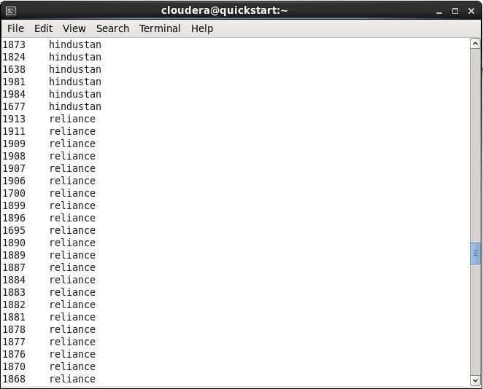

Use Case 2 – Olympic Dataset

Creating Table- create table olympic (athelete STRING,age INT,country STRING,year STRING,closing STRING,sport STRING,gold INT,silver INT,bronze INT,total INT) row format delimited fields terminated by ‘\t’ stored as textfile;

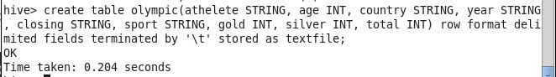

Query 1-

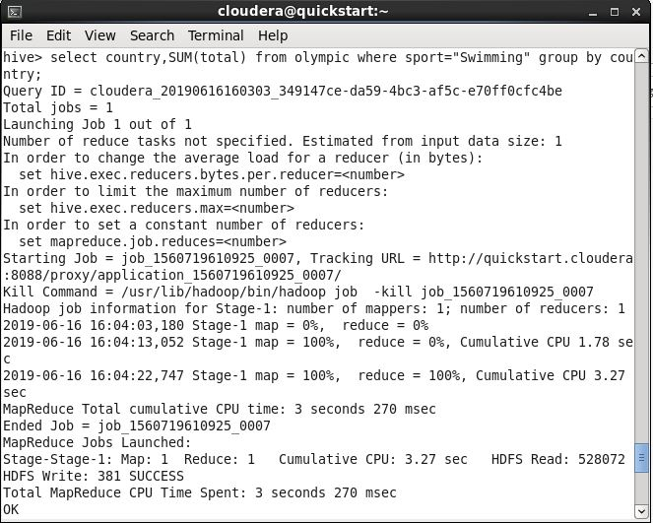

Output-

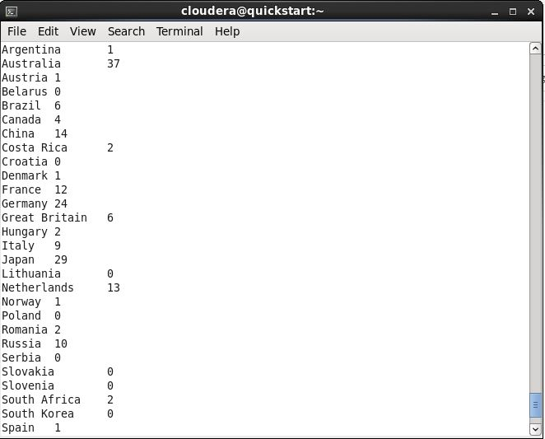

Query 2-

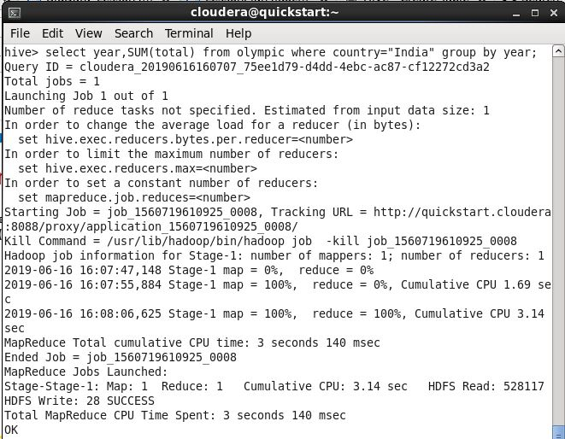

Output-

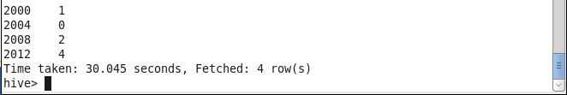

Query 3-

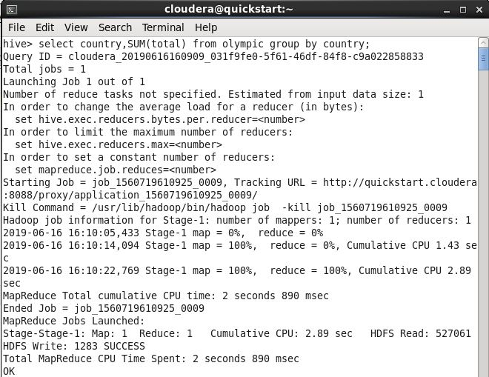

Output-

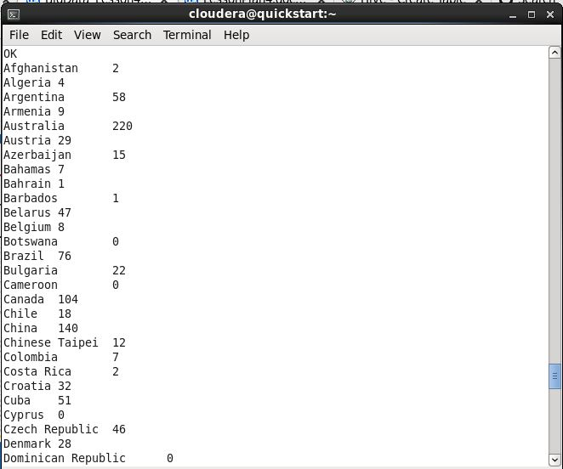

Query 4-

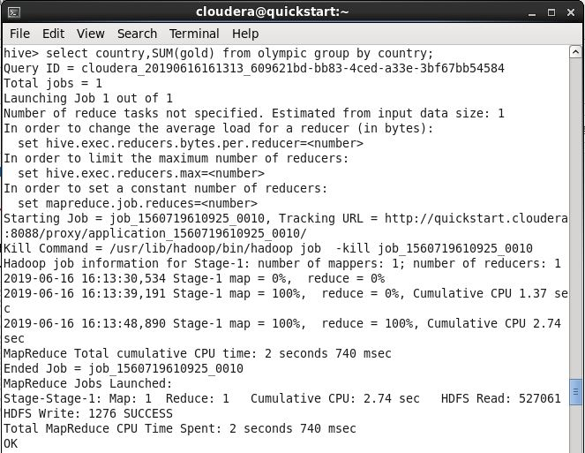

Output-

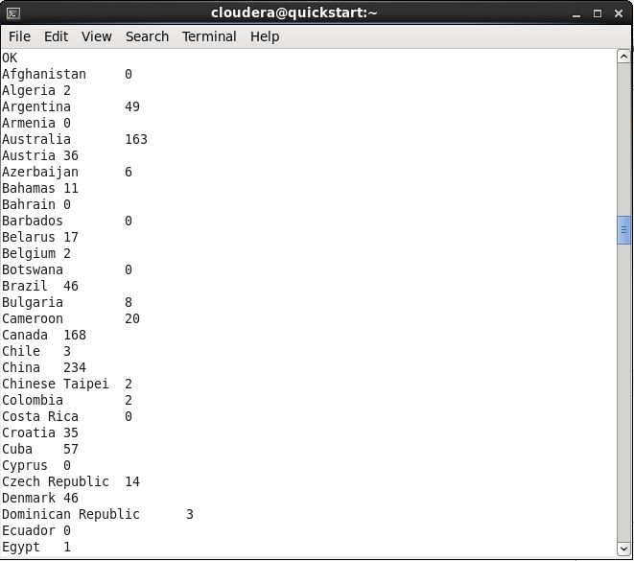

Query 5-

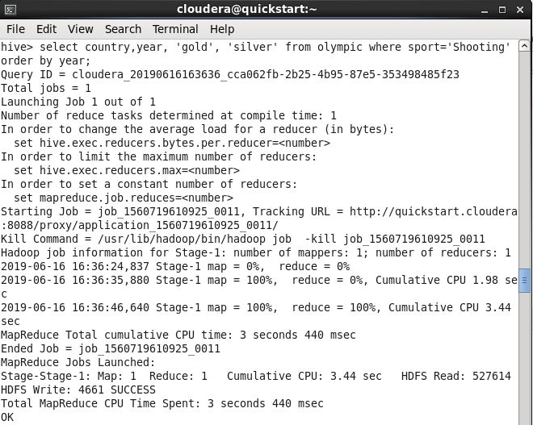

Output-

